Use Case Document for Java Microservices & AI: Pankaj Kumar Pal (CT35713)
MediGenie: Smart Patient & Appointment Management System with GenAI Integration

1. Project Overview
Build a web-based healthcare management system focused on managing patients, doctors, and appointments effectively with an added layer of intelligence using Generative AI (GenAI). The system will enable appointment scheduling, patient health monitoring, and support interaction with an AI-powered chatbot for enhanced patient engagement and appointment reminders.
The system is built using Java and Spring Boot, with GenAI integrated via API calls for chatbot and notification functionalities.

2. Actors
Actor | Description
Patient | Registers, schedules appointments, submits health logs, interacts with AI chatbot.
Doctor | Manages appointments, views patient information and health logs.
Admin | Manages users and system settings.
GenAI API | Provides AI-powered chatbot responses and generates appointment reminders.

3. Use Cases
3.1 User Authentication and Role Management
- Actors: Patient, Doctor, Admin
- Description:
Users register and log into the system with role-based access (patient, doctor, admin).
Secure authentication controls access to protected resources.
- Main Flow:
  - User registers with role selection.
  - User logs in with credentials.
  - User accesses resources based on role permissions.

3.2 Manage Patients
- Actors: Admin, Doctor
- Description:
Add, update, delete, and view patient information.
- Main Flow:
  - Admin/Doctor requests patient list or specific patient record.
  - Admin/Doctor performs CRUD operations on patient data.

3.3 Manage Doctors
- Actors: Admin
- Description:
Admin manages doctor profiles and details.
- Main Flow:
  - Admin views all doctors.
  - Admin adds new doctor or updates doctor information.

3.4 Appointment Scheduling & Management
- Actors: Patient, Doctor
- Description:
Patients request appointments with doctors, and doctors approve or reject them.
- Main Flow:
  - Patient views available doctors and schedules appointment.
  - Doctor reviews pending appointments and accepts/rejects requests.
  - Patient receives confirmation and reminder generated via GenAI.

3.5 Health Monitoring Logs
- Actors: Patient, Doctor
- Description:
Patients log daily health metrics (weight, symptoms, vitals), which doctors can view.
- Main Flow:
  - Patient submits daily health data via API or UI.
  - Doctor retrieves and reviews patient health logs.

3.6 AI-Powered Chatbot Interaction
- Actors: Patient
- Description:
Patients interact with a chatbot for FAQs, appointment help, and personalized advice.
- Main Flow:
  - Patient sends query to chatbot endpoint.
  - System relays query to GenAI API.
  - Chatbot returns an AI-generated response.

3.7 AI-Generated Appointment Reminders
- Actors: System, Patient
- Description:
System sends appointment reminders using AI-generated personalized messages.
- Main Flow:
  - System triggers reminders before appointment times.
  - GenAI API generates reminder text.
  - System sends notifications (email/SMS/log).

4. Non-Functional Requirements
- Security: Role-based access control; secure authentication (JWT or basic auth).
- Performance: APIs optimized for fast responses, suitable for concurrent users.
- Scalability: Modular service design enabling later microservices split.
- Usability: Simple REST APIs and optional minimal UI with Swagger or Thymeleaf.
- Extendibility: Easy integration with new GenAI features or external healthcare systems.
- Compliance: Data encryption and privacy following healthcare data standards (HIPAA guidelines preferred).

5. Technology Stack
- Backend: Java, Spring Boot, Spring Security, Spring Data JPA
- Database: H2 (development/testing), MySQL/PostgreSQL (production)
- AI Integration: Generative AI API (OpenAI or similar) for chatbot and text generation
- Build & Deployment: Maven, Docker (optional), Cloud deployment (Heroku, AWS)
- Testing: JUnit, Postman, Swagger/OpenAPI for API documentation

6. Assumptions & Constraints
- GenAI APIs are accessible and latency is manageable.
- Limited UI development due to tight timeline; focus on backend and API.
- Patient health log metrics are basic and extensible later.
- Notifications via email/SMS depend on external services or simulated logs.
- Security implementations are basic and require strengthening for production.

7. ER Diagram:
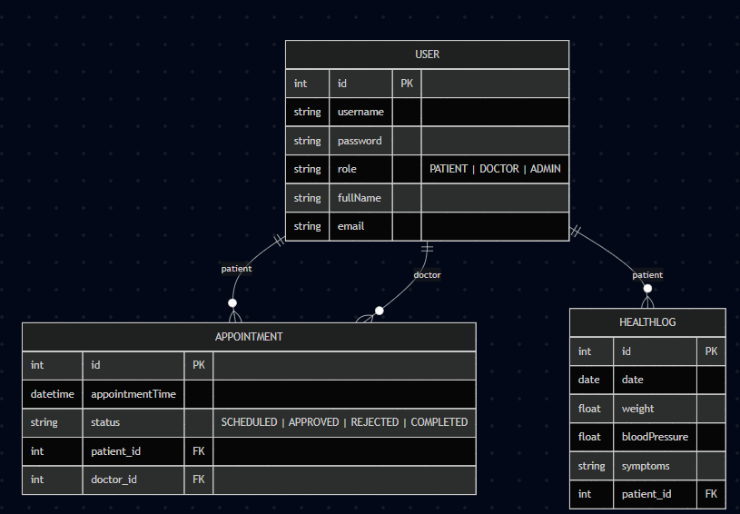
8. Flow Diagram:
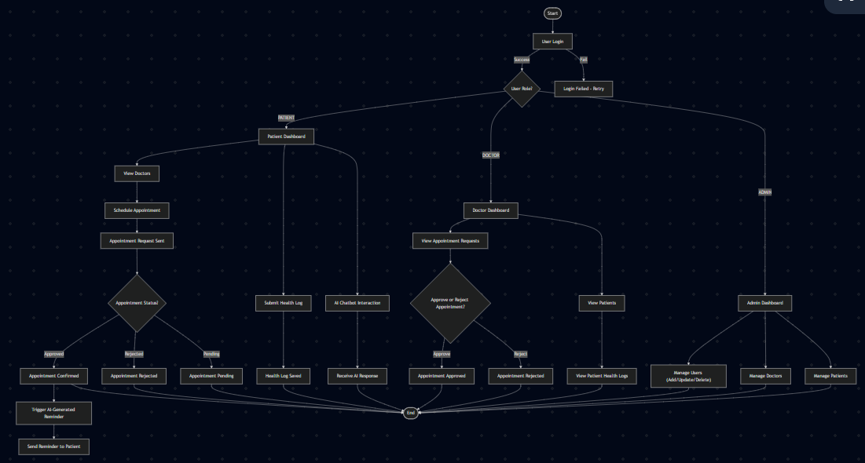

Flow 1: User Authentication and Role Routing
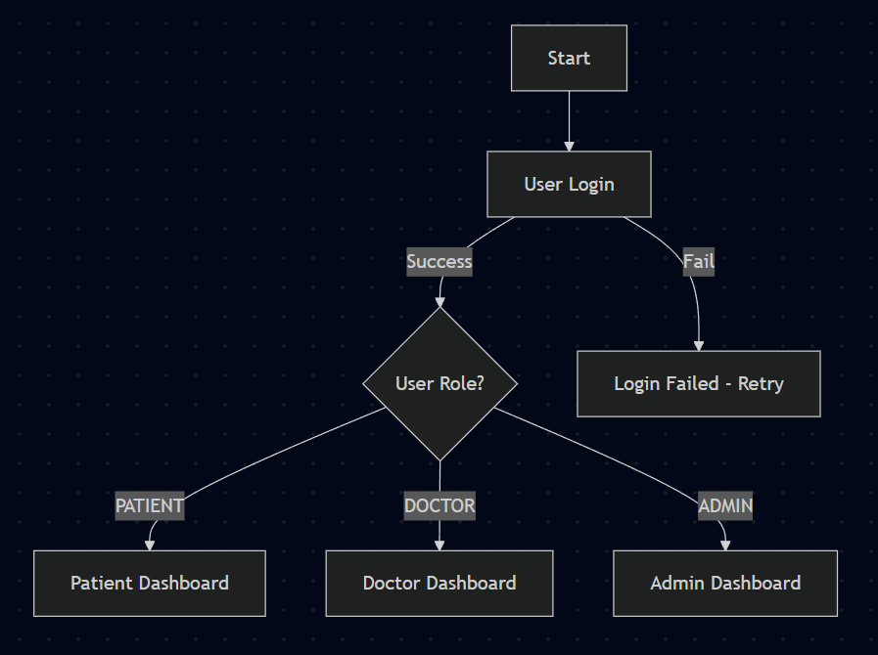

Flow 2: Patient Main Activities
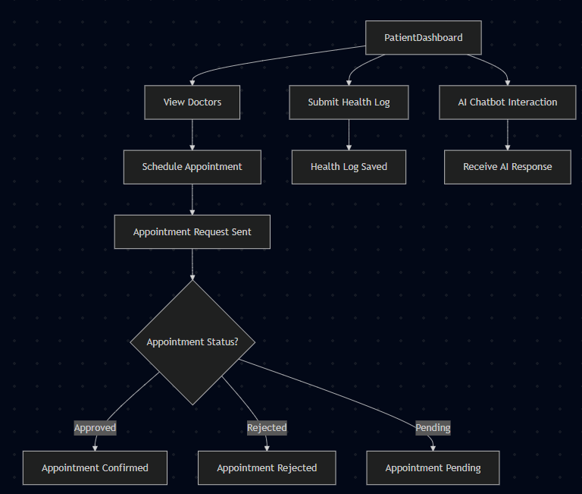
Flow 3: Doctor Activities
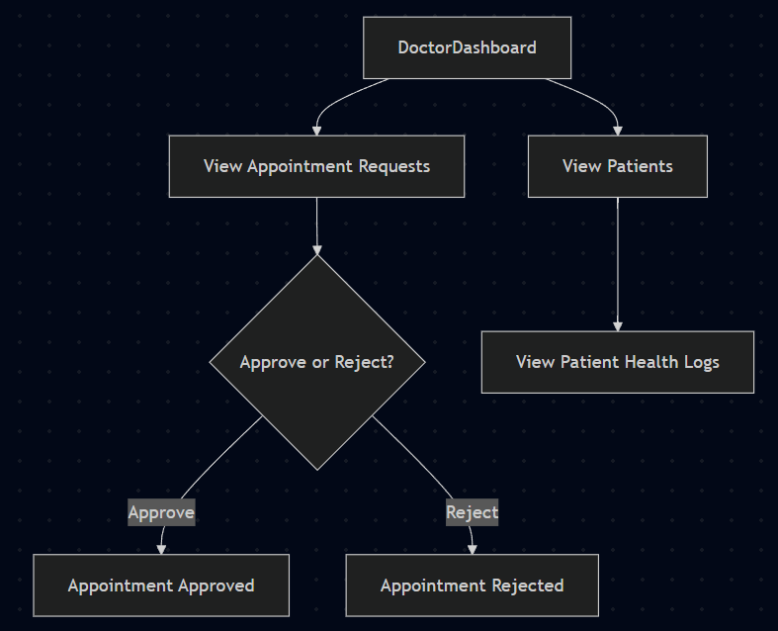

Flow 4: Admin Activities
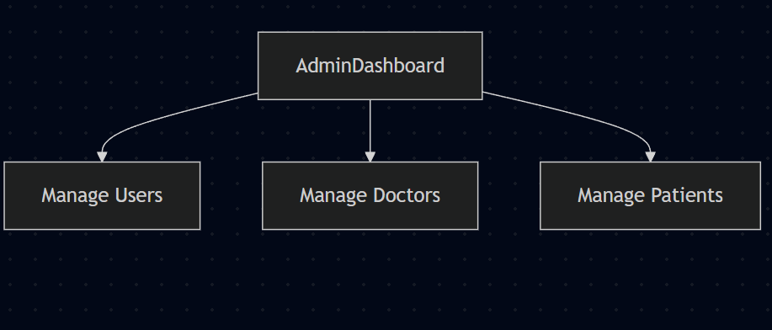
Flow 5: Appointment Reminder Flow
